Inside Case
MOTHERBOARD
The computer motherboard connects all the parts(components) of a computer. Mainboard, baseboard, mobo (abbreviation), system board, MB (abbreviation), the logic board are the synonyms of a computer’s motherboard. The motherboard is the most important component in the PC. All the components such as RAM stick, hard disk drive, optical drives, processor, processor fan, and external card are plugin into the motherboard. A computer motherboard is a single platform to connect all of the parts (components) of a computer, Hence it is considered as the backbone of a computer.
Some of the popular manufacturers of the motherboard.
Intel
ASUS
AOpen
ABIT
Biostar
Gigabyte
MSI

PORTS AND SLOTS

In the most easy-to-understand terms, "ports" are holes used to plug external devices into your computer. They will be found largely in the back of the computer. "Slots" are holes used to plug internal devices (sound/video cards...etc) INTO your computer. These will be found on the inside of your computer...and the devices you plug into will have "ports" on them...which will be able to be accessed from the back of the computer like the other ones.

Components of Motherboard
The important components of a Motherboard are given below:
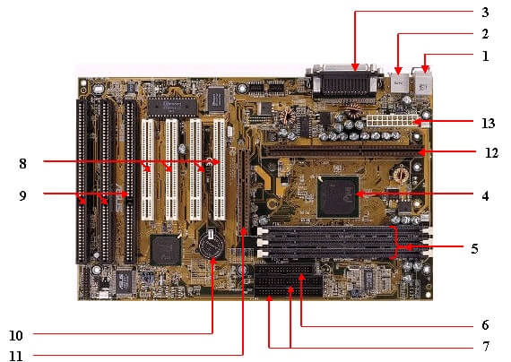

1. mouse & keyboard :
There are two types of keyboard and mouse connectors. The first type is called PS/2 and the second one is called USB.
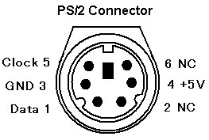
2. USB (Universal serial bus):
USB is a Universal serial bus. It is used for connection for PC. Different devices are used to connect with USB ports such as a mouse, keyboards, scanners, cameras, and even printers. The USB connector is used to connect a computer motherboard and a peripheral device. You can insert or remove peripheral devices connected by a USB connector without restarting your system.
3. Parallel port:
Most old printers are used to connect by the parallel port. Parallel port used more than one wire for sending or receiving multiple bits of data at once, while serial port uses only one wire. Parallel ports use a 25-pin female DB connector.
4. CPU Chip :
CPU refers to a processor, the central processing unit, also called the microprocessor performs all the tasks that take place inside a computer system. It is also known as the brain of the computer.
5. RAM slots :
RAM slots are for attaching RAM on it in general desktop we can see two slots of RAM but in server motherboard, we can see 4+ slots of RAM.RAM comes in different sizes (memory).
6. Floppy controller :
In the old motherboard, the floppy drive connects to the computer via a 34-pin ribbon cable, one end of the ribbon cable is connected to the floppy drive and the other is connected to the motherboard.
7. IDE controller :
IDE is Integrated Drive Electronics also called ATA or Parallel ATA (PATA).IDE controller is responsible for controlling the hard drive. Today’s computers no longer come with an IDE controller.
8. PCI slot :
PCI stands for Peripheral Component Interface, PCI slot allows you to insert expansion cards into your computer. PCI is used to connect additional PCI devices like network cards, sound cards, modems, video cards. Some of today’s computers no longer come with a PCI expansion slot. It connects audio, video, and graphics.
9. ISA slot :
ISA stands for Industry Standard Architecture, It is the standard architecture of the Expansion bus. Its connect modem and input devices.
10. CMOS Battery :
CMOS is complementary metal-oxide-semiconductor is used to store BIOS settings in the computer motherboard. CMOS Battery also stores the date and time.
11. AGP slot :
The Accelerated Graphics Port (AGP) is a high-speed point-to-point channel for attaching a video card to a computer system, If you have a modern motherboard, you will almost certainly notice a single connector that looks like a PCI slot. A fast port for a graphics card
12. CPU slot :
The processor socket (also called a CPU socket) is the connector on the motherboard that connects a CPU.
13. Power supply plugin :
The Power supply provides the necessary electrical power to make the computer system operate. The power supply takes standard 110-V AC power and converts into +/-12-Volt, +/-5-Volt, and 3.3-Volt DC power.
The power supply connector has 20-pins, and the connector can go in only one direction.
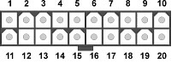

Connector Side of Motherboard

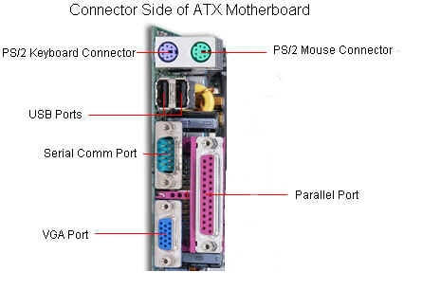

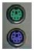 | Keyboard & Mouse: This Port is used to connect the keyboard and mouse, now a day we use a USB connector for the keyboard and mouse
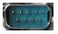 | Serial: It is used to connect some types of modem, scanner, or digital camera
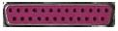 | Parallel or Printer: You plug your printer into the parallel, or printer, port. But now printers may use a USB port
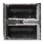 | USB: Designed to replace older Serial and Parallel ports, the USB (Universal Serial Bus) can connect computers with several devices, such as printers, keyboards, mice, scanners, digital cameras, PDAs, and more
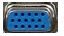 | Video or Monitor: It used to connect your monitor to the video port
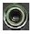 | Line Out: It is used to connect speakers or headphones into the Line Out jack
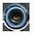 | Line In: The Line In jack allows you to listen to your computer using a stereo system
 | Microphone: It is used to connect a microphone into this jack to record sounds on your computer
 | Joystick or Game: If you have a joystick, musical (MIDI) keyboard, or another gaming device, this is where you plug it in
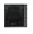 | Phone or Modem: The phone or modem jack is where you plug your computer into a phone line
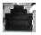 | Network or Ethernet: You can connect your computer to a network by plugging in an Ethernet cable in this port
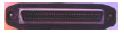 | SCSI: It used to connect a hard drive, CD-ROM drive, or another device to a computer

Installing components of the motherboard
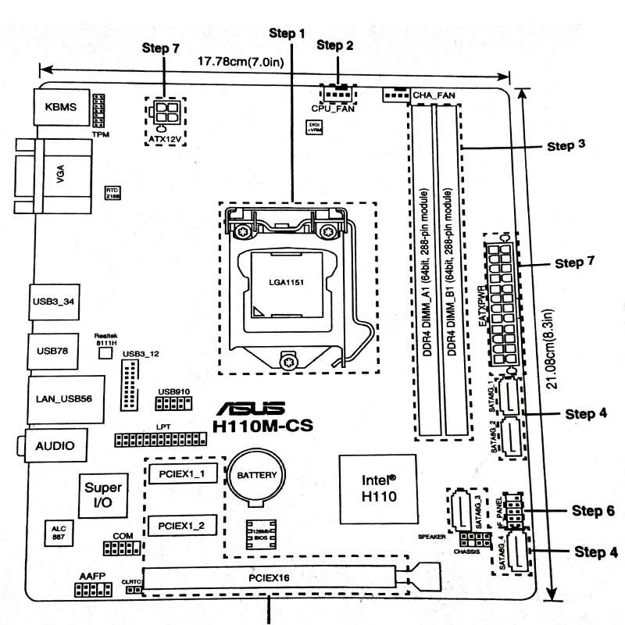

Step 1 ) Install CPU

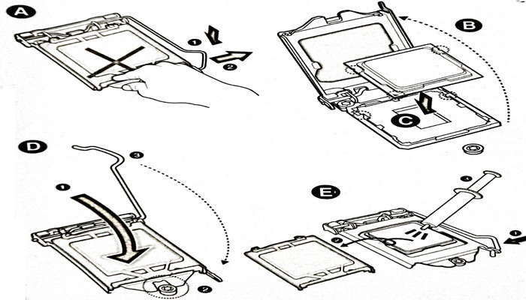

Step 2 ) Installing CPU Fan

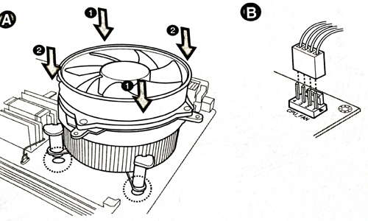

Step 3 ) Install RAM
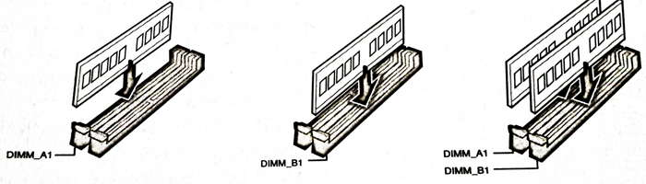

Step 4 ) Install SATA devices

Step 5 ) Install Expansion cards

Step 6 ) Install system panel connector

Step 7 ) Install ATX power connector
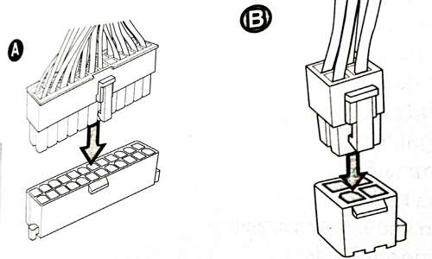

Step 8 ) Connecting input/output devices

Step 9 ) Power On the system and install Operating System

Central Processing Unit
The processor is a chip or a logical circuit that responds and processes the basic instructions to drive a particular computer. The main functions of the processor are fetching, decoding, executing, and writing back the operations of an instruction. The processor is also called the brain of any system which incorporates computers, laptops, smartphones, embedded systems, etc.

